|  |
| --- |
| **National University of Computer and Emerging Sciences** |
| In Lab Exercise 4  “Data Retrieval Select-from-where Join Order by” |
|  |
| Database Systems |
| Spring 2018 |

Department of Computer Science

FAST-NU, Lahore, Pakistan

# Exercise

For this exercise use the following schema, the script to create this schema and populate data is given in Neon.SQL file.

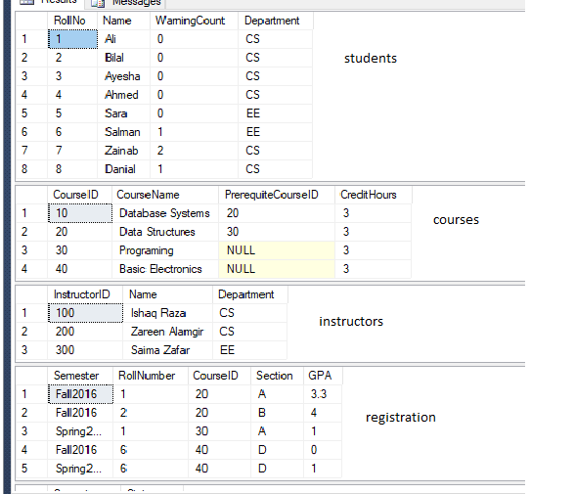

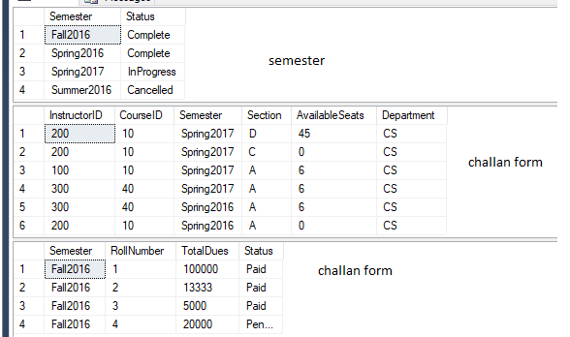

1. List all students who have 0 warning count and list their names in ascending order.
2. List all the roll numbers who have pending fee.
3. List all the students and their GPA’s who have GPAs between 3 and 4(Hint use between keyword).
4. List the names of the instructors who have no more available seats in their sections in spring 2017.
5. List all the instructors whio never took a class.
6. Show the student who had minimum dues to pay.
7. List all the Sudents with name starting with A
8. List names of all the students and all the couses they have taken in case a student has not taken any course show 0 or null in his courses.(Hint use ISNULL function)
9. Show total number of credit hours a student has studied in any semester. (Semester wise).